KAKINADA INSTITUTE OF ENGINEERING & TECHNOLOGY (KIET GROUP)
Unified NGO Management and Collaboration Platform
━━━━━━━━━━━━━━━━━━━━━━━━━━━━━━━━━━━━━━━Solution Architecture Document: From Problem to Architecture
━━━━━━━━━━━━━━━━━━━━━━━━━━━━━━━━━━━━━━━C4GT Hub | C4GT - Team 1
Davuluri Bala Veera Venkata Bhavani Sankar (Team Lead)
Kolamuri Bhavya Sri | Mallipudi Satya Krupa
Bolisetti Jyothi Swarupa | Siri Bhuvaneswari
Panasa Rajini | Dasari Naveen Kumar
Mamidala Govind | Sabbisetty Anjana Lakshmi Asritha
Project Mentor: G. Sai Varshitha | Industry Mentor: L. Krishna Deepika Mam
October 2026
Team Contributions & Scope Ownership
Document Section & Scope | Assigned Contributor
Problem Statement, Context & Project Constraints | Davuluri Bala Veera Venkata Bhavani Sankar (Team Lead)
Assumptions, Unresolved Questions & System Boundary | Mamidala Govind
Actors, Use Cases, Functional & Quality Requirements | Sabbisetty Anjana Lakshmi Asritha
Component Architecture, Architecture Diagram & Data Flows | Mallipudi Satya Krupa
Beneficiary Identity Design, Aadhaar Vault & Data Ownership | Siri Bhuvaneswari
Detailed User Flows, Sequence Diagrams & Offline Synchronization | Panasa Rajini
Edge Cases, Failure Scenarios & Test Strategy | Dasari Naveen Kumar
Design Decisions, Self-Review & Out-of-Scope Roadmap | Kolamuri Bhavya Sri
Database Schema, Entity Relationships & Data Integrity | Bolisetti Jyothi Swarupa
Contents
1. Overview 4
The design in brief 4
1. Six user roles. 4
2. Problem Statement and Assumptions 5
2.1 The problem 5
2.2 Intended users 5
2.3 Architectural constraints 5
2.4 Assumptions 6
2.5 Unresolved questions 6
3. Actors and Use Cases 7
3.1 Actors 7
3.2 Key use cases 8
3.3 Simple Use Case Descriptions 8
Platform Administrator 8
NGO Administrator 9
NGO Staff 9
Volunteer 9
Donor 9
Beneficiary / Public User 9
3.3 Role-based access control 10
4. Functional Requirements 10
5. System Boundary 12
Inside and outside the system 12
6. High-Level Architecture and Component Responsibilities 13
6.1 Architectural principles 13
6.2 Architecture diagram 13
6.3 Component responsibilities 14
7. Data Flow 15
7.2 Data flow catalogue 16
7.3 Domain events 17
8. Detailed NGO Registration and Verification Workflow 18
8.1 Scenario and starting conditions 18
8.2 The flow at a glance 18
8.3 NGO Collaboration Workflow 20
9. Security 21
10. Self-Review 22
Review against the assignment questions 22

Overview
━━━━━━━━━━━━━━━━━━━━━━━━━━━━━━━━━━━━━━━
This document describes the architecture of a proposed Unified NGO Management, Resource Coordination and Collaboration Platform. It is a design document: nothing described here has been built or deployed. It is written so that a developer who was not part of the team can read and understand the design without a verbal explanation, and so that the team has a shared reference for implementation decisions.
In one sentence: the platform gives every registered NGO a shared digital profile, project workspace, volunteer management hub, resource coordination centre, and collaboration channel, all accessible from a single web portal with role-based access for administrators, staff, volunteers, donors, and beneficiaries.
Core operational boundary: the platform organises information, facilitates discovery, and coordinates resources. It does not process financial transactions, provide legal certification, or replace government regulatory processes.
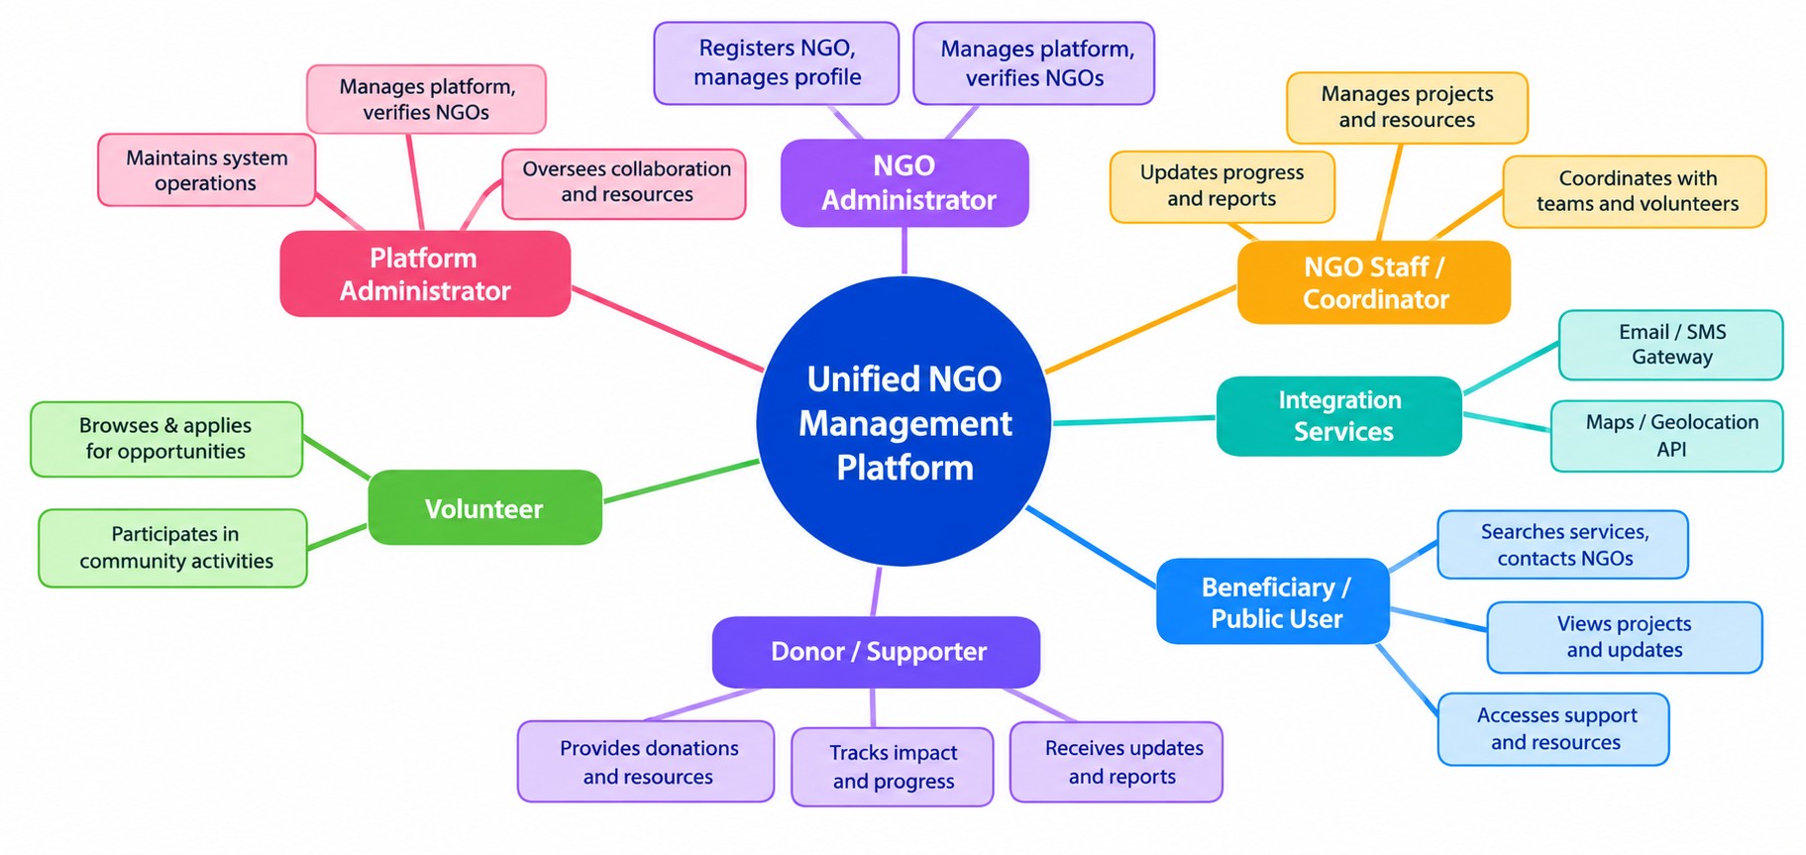

Figure 1: System Context Diagram - problem, actors, platform boundary, and external services

The design in brief
- Six user roles. Platform Administrators verify NGOs and manage the platform, NGO Administrators register and manage their organisations, NGO Staff coordinate projects and resources, Volunteers discover and apply for opportunities, Donors identify NGO needs and track contributions, and Beneficiaries search for services.
- Five core workflows. Register and verify NGOs, manage projects and activities, coordinate volunteer opportunities, publish and track resource requirements, and facilitate collaboration between NGOs.
- Two supporting operations. Notification management delivers status updates and alerts, while administration dashboards provide platform-wide reporting and oversight.
- Checks at the perimeter. Every external request passes through an API Gateway that validates the session token and user role before allowing access to business modules.
- One identity per NGO. Duplicate detection checks the official NGO registration number during registration to prevent multiple profiles for the same organisation.
- Administrator-verified trust. NGOs remain hidden from the public directory until a Platform Administrator reviews and approves their registration details and supporting documentation.
- Verify before visibility. No NGO becomes publicly discoverable until its identity and registration documents have been reviewed and approved.

2. Problem Statement and Assumptions
━━━━━━━━━━━━━━━━━━━━━━━━━━━━━━━━━━━━━━━

2.1 The problem
Non-governmental organisations (NGOs) working across education, healthcare, poverty alleviation, environment, and community development face a persistent coordination challenge. Information about their services, ongoing projects, volunteer needs, and resource requirements is scattered across separate websites, social media pages, government registries, and paper records. This fragmentation creates several compounding problems:
- Scattered information. NGO profiles, project details, volunteer needs, and resource requirements sit in separate platforms, so there is no unified picture of the social sector landscape.
- Difficult partner discovery. NGOs working in complementary sectors or overlapping geographies cannot easily find each other for collaboration, leading to duplicated efforts and missed synergies.
- Inefficient volunteer matching. Volunteers with specific skills and availability cannot efficiently discover suitable opportunities across multiple organisations.
- Opaque resource needs. Donors and supporters lack a centralised view of what NGOs actually need, leading to mismatched contributions and unfulfilled requirements.
- Beneficiary access barriers. People seeking services — food distribution, education programmes, healthcare camps, legal aid — must search across many fragmented sources to find relevant NGOs.
- No trust verification. Without a centralised verification mechanism, volunteers and donors cannot easily distinguish legitimate, active NGOs from inactive or unverified entities.
- Knowledge loss. When an NGO coordinator leaves, their personal contacts, informal partnerships, and institutional knowledge leave with them.
The proposed platform creates a single, administrator-verified digital ecosystem where NGOs register, publish their work, coordinate resources, find partners, and serve beneficiaries — all through one portal with structured data, role-based access, and transparent verification.

2.2 Intended users
The direct users are Platform Administrators, NGO Administrators, NGO Staff/Coordinators, Volunteers, Donors/Supporters, and Beneficiaries/Public Users. Government regulators, partner hospitals, schools, and other institutional entities interact with NGOs outside the platform. Section 3 describes each actor in detail.

2.3 Architectural constraints
Seven constraints are fixed inputs to the design. They are not assumptions: each one shapes a specific architectural choice.
ID | Constraint | Architectural Impact
C-1 | Web-based access only - no native mobile app in Phase 1 | Responsive web application using a single-page architecture; CSS media queries for mobile/tablet layouts
C-2 | Platform administrator must verify every NGO before public listing | Verification workflow with PENDING → VERIFIED → REJECTED state machine; unverified NGOs invisible in public directory
C-3 | No online payment processing | Donation module tracks published resource needs and manually logged contributions; no payment gateway integration
C-4 | Single deployment unit for Phase 1 | Modular monolith with strict module boundaries; shared PostgreSQL database with per-module schemas; migration path to services in Phase 2
C-5 | All user-uploaded documents must be stored securely | Separate document/file storage with access control; documents linked to NGO records via references, not embedded in database
C-6 | Role-based access control for all operations | JWT-based authentication with role claims; API Gateway validates token and role before routing to business modules
C-7 | Platform must support multiple concurrent NGOs | Multi-tenant data model with ngo_id as a partition key on all NGO-specific tables; data isolation enforced at the query level

2.4 Assumptions
Assumptions are statements the design relies on but that have not been independently confirmed. The last column shows what would have to change if an assumption proved wrong.
ID | Assumption | Impact if Wrong
A-1 | NGOs have a government-issued registration number that uniquely identifies them | Duplicate detection would need alternative matching criteria (name + address + sector fuzzy matching)
A-2 | At least one Platform Administrator is available to review registrations within 48 hours | Unverified NGOs accumulate; may need auto-escalation or tiered review delegation
A-3 | NGO Administrators have email addresses for notification delivery | Would need to add SMS or WhatsApp as primary notification channels
A-4 | Uploaded documents (certificates, proofs) are in PDF or standard image formats | Would need document conversion pipeline for non-standard formats
A-5 | The platform will initially serve NGOs in a single country with one language | Multi-language and multi-currency support would require internationalisation framework
A-6 | Volunteers self-register and self-report their skills; no external skill verification | Would need integration with professional certification databases
A-7 | Resource contributions are tracked via manual entry by NGO staff, not automated receipts | Would need donor-side confirmation workflow and two-party verification
A-8 | The initial user base is under 500 NGOs and 5,000 users | Would need database read replicas, caching layer, and horizontal scaling strategy earlier

2.5 Unresolved questions
The questions below are shared team items awaiting clarification from stakeholders and partner NGOs. Until they are answered, the design follows the interim default shown.
ID | Question | Interim Working Default
Q-1 | Should NGOs be able to re-submit after rejection, or must they create a new registration? | Allow re-submission with updated documents; keep rejection history for audit
Q-2 | What is the maximum document upload size for verification? | 10 MB per file, 50 MB total per NGO registration
Q-3 | Should volunteers be able to apply for opportunities at unverified NGOs? | No; only verified NGOs can publish volunteer opportunities
Q-4 | How long should collaboration requests remain pending before auto-expiry? | 30 days; after which the request status changes to EXPIRED
Q-5 | Should the platform send reminder notifications for overdue project milestones? | Yes; weekly digest emails for projects with overdue milestones
Q-6 | What categories and sectors should be pre-defined vs. user-created? | Pre-define 20 standard sectors (education, health, environment, etc.); allow NGOs to add custom tags
Q-7 | Should beneficiary contact inquiries be anonymous or require registration? | Allow anonymous inquiries with optional contact details; no login required

3. Actors and Use Cases
━━━━━━━━━━━━━━━━━━━━━━━━━━━━━━━━━━━━━━━

3.1 Actors
Six authenticated human actors use the system. External parties such as government regulators, partner institutions, and the general public interact with NGOs outside the platform boundary.
Actor | Type | Role in the System
Platform Administrator | Internal, authenticated | Reviews and verifies NGO registrations. Manages platform-wide settings, user accounts, categories, and tags. Views platform analytics and generates reports. Can suspend or reactivate NGO accounts.
NGO Administrator | External, authenticated | Registers the NGO on the platform and submits verification documents. Manages the NGO's profile, staff accounts, and organisational details. Initiates collaboration requests with other NGOs. Views NGO-level reports.
NGO Staff / Coordinator | External, authenticated | Creates and manages projects and activities under the NGO. Publishes volunteer opportunities and reviews applications. Publishes resource requirements and logs resource receipts. Tracks project progress and outcomes.
Volunteer | External, authenticated | Creates a volunteer profile with skills and availability. Browses and searches for volunteer opportunities. Applies for opportunities and tracks application status. Views personal volunteer activity history.
Donor / Supporter | External, authenticated | Browses NGO resource needs and published requirements. Views verified NGO profiles and project details. Contacts NGOs to offer support. Tracks published contributions.
Beneficiary / Public User | External, minimal or no auth | Searches for NGOs by service type, sector, or location. Views public NGO profiles and project details. Contacts NGOs for assistance through an inquiry form. Does not require login for browsing.

3.2 Key use cases

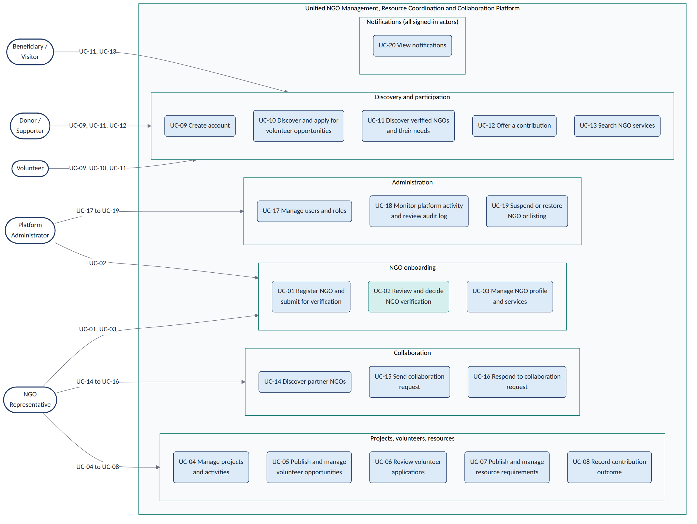
Figure 2: Actor and Use-Case Diagram

3.3 Simple Use Case Descriptions

Platform Administrator
UC-01 Review NGO applications. The admin checks NGO registration applications.
UC-02 Approve or reject NGOs. The admin approves or rejects NGOs after checking their documents.
UC-03 Manage NGO accounts. The admin suspends or reactivates NGO accounts.
UC-04 Manage user accounts. The admin creates, updates, or deactivates user accounts.
UC-05 View platform reports. The admin views overall platform statistics.
UC-06 Manage categories. The admin adds or updates categories and tags.

NGO Administrator
UC-07 Register NGO. The NGO admin registers the organisation on the platform.
UC-08 Upload documents. The NGO admin uploads documents for verification.
UC-09 Update NGO profile. The NGO admin updates NGO details and contact information.
UC-10 Manage staff. The NGO admin creates staff accounts and assigns roles.
UC-11 View reports. The NGO admin and authorised staff view NGO reports.
UC-12 Request collaboration. An NGO sends a collaboration request to another NGO.

NGO Staff
UC-13 Manage projects. Staff create projects and update their progress.
UC-14 Publish volunteer opportunities. Staff post opportunities for volunteers.
UC-15 Manage volunteer applications. Staff review and accept or reject applications.
UC-16 Publish resource needs. Staff list the resources their NGO needs.
UC-17 Manage resources. Staff record received and distributed resources.
UC-18 Track project progress. Staff update project activities and results.

Volunteer
UC-19 Create volunteer profile. Volunteers register and add their skills.
UC-20 Search opportunities. Volunteers find suitable opportunities.
UC-21 Apply for opportunities. Volunteers submit applications.
UC-22 Track applications. Volunteers check their application status.
UC-23 View activity history. Volunteers view their past activities.

Donor
UC-24 View resource needs. Donors check what resources NGOs need.
UC-25 View NGO profiles and projects. Donors, volunteers, and beneficiaries view NGO details and projects.
UC-26 Contact NGO. Donors contact NGOs to offer support.
UC-27 Track contributions. Donors check their contribution history.

Beneficiary / Public User
UC-28 Search NGOs. Users find NGOs by service or location.
UC-29 View NGO services. Users check NGO details and available services.
UC-30 Request assistance. Beneficiaries contact NGOs for help.

3.3 Role-based access control
Access follows the principle of least privilege: each role receives only the permissions it needs. Roles are checked on the server for every endpoint; hiding a button in the user interface is never treated as security.
Permission | Platform Admin | NGO Admin | NGO Staff | Volunteer | Donor | Beneficiary
Create / Edit own user profile | ✓ | ✓ | ✓ | ✓ | ✓ | -
Register a new NGO | - | ✓ | - | - | - | -
Approve / Reject NGO registrations | ✓ | - | - | - | - | -
Manage NGO profile (own NGO) | - | ✓ | ✓ | - | - | -
Create / Edit projects (own NGO) | - | - | ✓ | - | - | -
Publish volunteer opportunities (own NGO) | - | - | ✓ | - | - | -
Apply for volunteer opportunities | - | - | - | ✓ | - | -
View resource needs (all verified NGOs) | - | - | - | - | ✓ | ✓
Log resource receipts (own NGO) | - | - | ✓ | - | - | -
Access platform admin dashboard | ✓ | - | - | - | - | -

4. Functional Requirements
━━━━━━━━━━━━━━━━━━━━━━━━━━━━━━━━━━━━━━━
ID | Priority | Owner Component | Requirement
FR-01 | Must | Authentication & Authorization | The system must allow users to register with email and password, and authenticate via JWT tokens with role claims.
FR-02 | Must | NGO Registration & Verification | The system must allow NGO Administrators to submit registration forms with organisation details and upload verification documents.
FR-03 | Must | NGO Registration & Verification | The system must support a verification workflow where Platform Administrators review, approve, or reject NGO registrations with remarks.
FR-04 | Must | NGO Registration & Verification | The system must check for duplicate NGO registrations using the official registration number.
FR-05 | Must | NGO Directory & Search | The system must provide a searchable directory of verified NGOs filterable by sector, location, and services offered.
FR-06 | Must | Project & Activity Management | The system must allow NGO Staff to create, update, and close projects with title, description, category, timeline, and target location.
FR-07 | Must | Volunteer Management | The system must allow NGO Staff to publish volunteer opportunities linked to projects, specifying skills, location, dates, and available slots.
FR-08 | Must | Volunteer Management | The system must allow Volunteers to browse opportunities, apply with a cover note, and track application status.
FR-09 | Must | Volunteer Management | The system must allow NGO Staff to accept or reject volunteer applications and notify applicants of the decision.
FR-10 | Must | Donation & Resource Requirement Mgmt | The system must allow NGO Staff to publish resource requirements with type, quantity, priority, and fulfilment status.
FR-11 | Should | Donation & Resource Requirement Mgmt | The system should allow NGO Staff to log resource receipts against published requirements, updating fulfilment status.
FR-12 | Must | NGO Collaboration Management | The system must allow NGO Administrators to search for partner NGOs and send collaboration requests with type, scope, and duration.
FR-13 | Must | NGO Collaboration Management | The system must allow the target NGO to accept or decline collaboration requests with remarks.
FR-14 | Must | Beneficiary Service Discovery | The system must allow Beneficiaries to search for NGOs and services by need, sector, or location without requiring login.
FR-15 | Should | Beneficiary Service Discovery | The system should allow Beneficiaries to submit contact inquiries to NGOs through a form.
FR-16 | Must | Notification Management | The system must send email notifications for registration status changes, collaboration requests, volunteer application updates, and beneficiary inquiries.
FR-17 | Must | Notification Management | The system must maintain an in-app notification feed for each authenticated user.
FR-18 | Must | Administration & Reporting | The system must provide Platform Administrators with dashboards showing NGO registration statistics, user counts, and platform activity summaries.
FR-19 | Should | Administration & Reporting | The system should allow Platform Administrators to export reports in CSV format.
FR-20 | Could | NGO Directory & Search | The system could integrate with a maps/geolocation API to show NGO locations on an interactive map.

5. System Boundary
━━━━━━━━━━━━━━━━━━━━━━━━━━━━━━━━━━━━━━━

Inside and outside the system
The boundary separates what the software does from the real-world work that people and institutions do. The software records, organises, and facilitates discovery; people make decisions, deliver services, and manage actual resources.
Inside the Boundary (Software) | Outside the Boundary (People and Institutions)
Register and store NGO profiles with structured data | Verify the physical existence and legitimacy of an NGO through site visits or external audits
Manage a verification workflow with document upload, admin review, and status transitions | Issue official government registration certificates or tax exemption documents
Publish and search volunteer opportunities with skill and location filters | Conduct background checks on volunteers or verify their claimed skills
Record and track resource requirements and manually logged contributions | Process financial transactions, issue tax receipts, or manage bank transfers
Facilitate inter-NGO collaboration through structured request and response workflows | Negotiate legal agreements, memoranda of understanding, or contractual terms between NGOs
Send email and in-app notifications for status changes and new activities | Deliver SMS via telecom providers (future integration); make phone calls to beneficiaries
Provide a searchable directory of verified NGOs with public profiles | Certify that an NGO's services meet quality standards or regulatory requirements
Generate platform-level analytics and administrative reports | Conduct financial audits, compliance reviews, or impact assessments

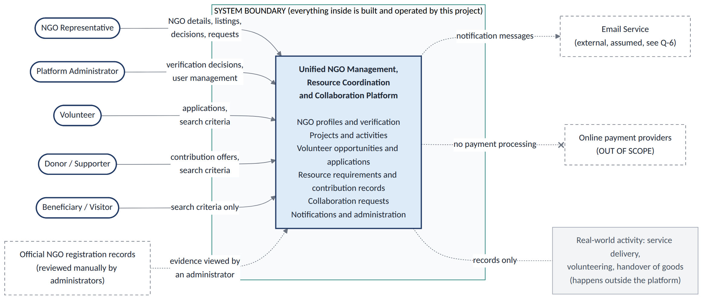
Figure 3: System Context Diagram - platform boundary with actors and external services

6. High-Level Architecture and Component Responsibilities
━━━━━━━━━━━━━━━━━━━━━━━━━━━━━━━━━━━━━━━

6.1 Architectural principles
Seven Key Design Principles
- Verification-first trust. Only approved NGOs appear in the public directory.
- Clear data ownership. Each module manages its own data and communicates through defined interfaces.
- Secure API Gateway. Every request passes through security checks before processing.
- Role-based access. Users can access only the features and data allowed for their roles.
- Modular design. Start with one application divided into modules, allowing them to become separate services later.
- Centralised notifications. One module manages notifications through email and in-app messages.
- NGO data isolation. Each NGO can access only its own private data, keeping organisations' information separate.

6.2 Architecture diagram
Figure 4 shows the system in four tiers. The client tier is the responsive web application. The edge tier is the API Gateway, the only entry point. The application tier contains ten business modules, each with one clear responsibility. The data tier holds the PostgreSQL database and document storage. Two external services — Email/SMS Gateway and Maps/Geolocation API — sit outside the platform boundary.
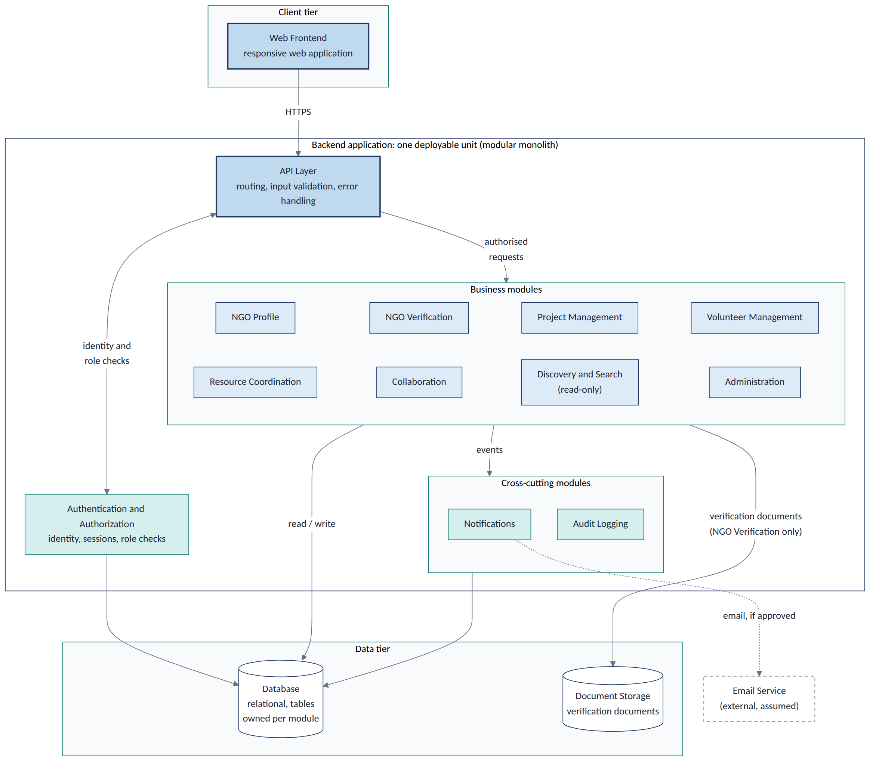
Figure 4: High-Level System Architecture - tiers, modules, and data stores

6.3 Component responsibilities
The system is split into twelve components, each with one clear purpose and its own data.
No | Component | Purpose and Responsibilities | Data Owned | Depends On
1 | User Interface / Web Portal | Responsive single-page web application that renders dashboards, forms, search results, and notifications for all user roles. Handles client-side validation and session management. | Session tokens, UI state | API Gateway
2 | API Gateway | Single entry point for all client requests. Terminates TLS, applies rate limiting, validates JWT tokens, checks user roles, and routes requests to the appropriate business module. | Rate-limit counters, route configuration | Authentication module
3 | Authentication & Authorization | Manages user registration, login, password reset, and JWT token issuance. Stores user credentials and role assignments. Validates tokens for the API Gateway on every request. | User accounts, credentials, role assignments, sessions | PostgreSQL
4 | NGO Registration & Verification | Handles NGO registration form submission, document upload, duplicate detection (by registration number), verification state machine (PENDING → VERIFIED / REJECTED / SUSPENDED), and administrator review workflow. | NGO records, verification requests, uploaded document references | Authentication, Document Storage, Notification
5 | NGO Directory & Search | Indexes verified NGO profiles and provides search/filter capabilities by sector, location, services, and tags. Serves the public-facing NGO directory and profile pages. | Search indices, cached NGO summaries | Registration & Verification, PostgreSQL
6 | Project & Activity Management | Manages the lifecycle of projects and activities within an NGO — creation, update, status tracking (PLANNING → ACTIVE → COMPLETED), milestone management, and closure. | Project records, activity logs, milestones | Authentication, PostgreSQL
7 | Volunteer Management | Manages volunteer opportunity publication, application submission, acceptance/rejection workflows, volunteer profile management, and activity history tracking. | Volunteer profiles, opportunities, applications, assignments | Project Management, Authentication, Notification
8 | Donation & Resource Requirement Management | Manages the publication of resource requirements (type, quantity, priority), logging of resource receipts, fulfilment status tracking, and donor-side browsing of needs. | Resource requirements, resource records, donor contact logs | Project Management, Authentication, Notification
9 | NGO Collaboration Management | Facilitates inter-NGO collaboration through partner discovery (via Directory), structured request/response workflow (PENDING → ACTIVE / DECLINED), and collaboration tracking. | Collaboration requests, partnership records | Directory & Search, Authentication, Notification
10 | Beneficiary Service Discovery | Provides a public-facing search interface for beneficiaries to find NGOs and services by need, sector, or location. Handles anonymous contact inquiries to NGOs. | Contact inquiry records | Directory & Search, Notification
11 | Notification Management | Receives events from other modules (registration status, application updates, collaboration requests, inquiries) and dispatches notifications via email and in-app feed. Manages user notification preferences. | Notification records, delivery logs, user preferences | Email/SMS Gateway (external)
12 | Administration & Reporting | Provides Platform Administrators with dashboards, registration queue management, user account management, platform analytics, and report generation (CSV export). | Report definitions, analytics cache, audit logs | All business modules (read-only queries)

7. Data Flow
━━━━━━━━━━━━━━━━━━━━━━━━━━━━━━━━━━━━━━━7.1 How Data Moves Through the System
- User action. The user performs an action on the web portal, and the client sends an HTTPS request with a JWT token.
- Gateway security. The API Gateway checks the token, user role, and request limits. Invalid requests are rejected with a 401 or 403 status.
- Business processing. The correct module handles the request, validates the input, and applies business rules.
- Data storage. The module saves data in its own PostgreSQL schema. Uploaded documents are stored separately.
- Response. The result is returned to the user through the API Gateway without waiting for notifications to finish.
- Events and notifications. The module generates an event, and the Notification module uses it to send email or in-app notifications.

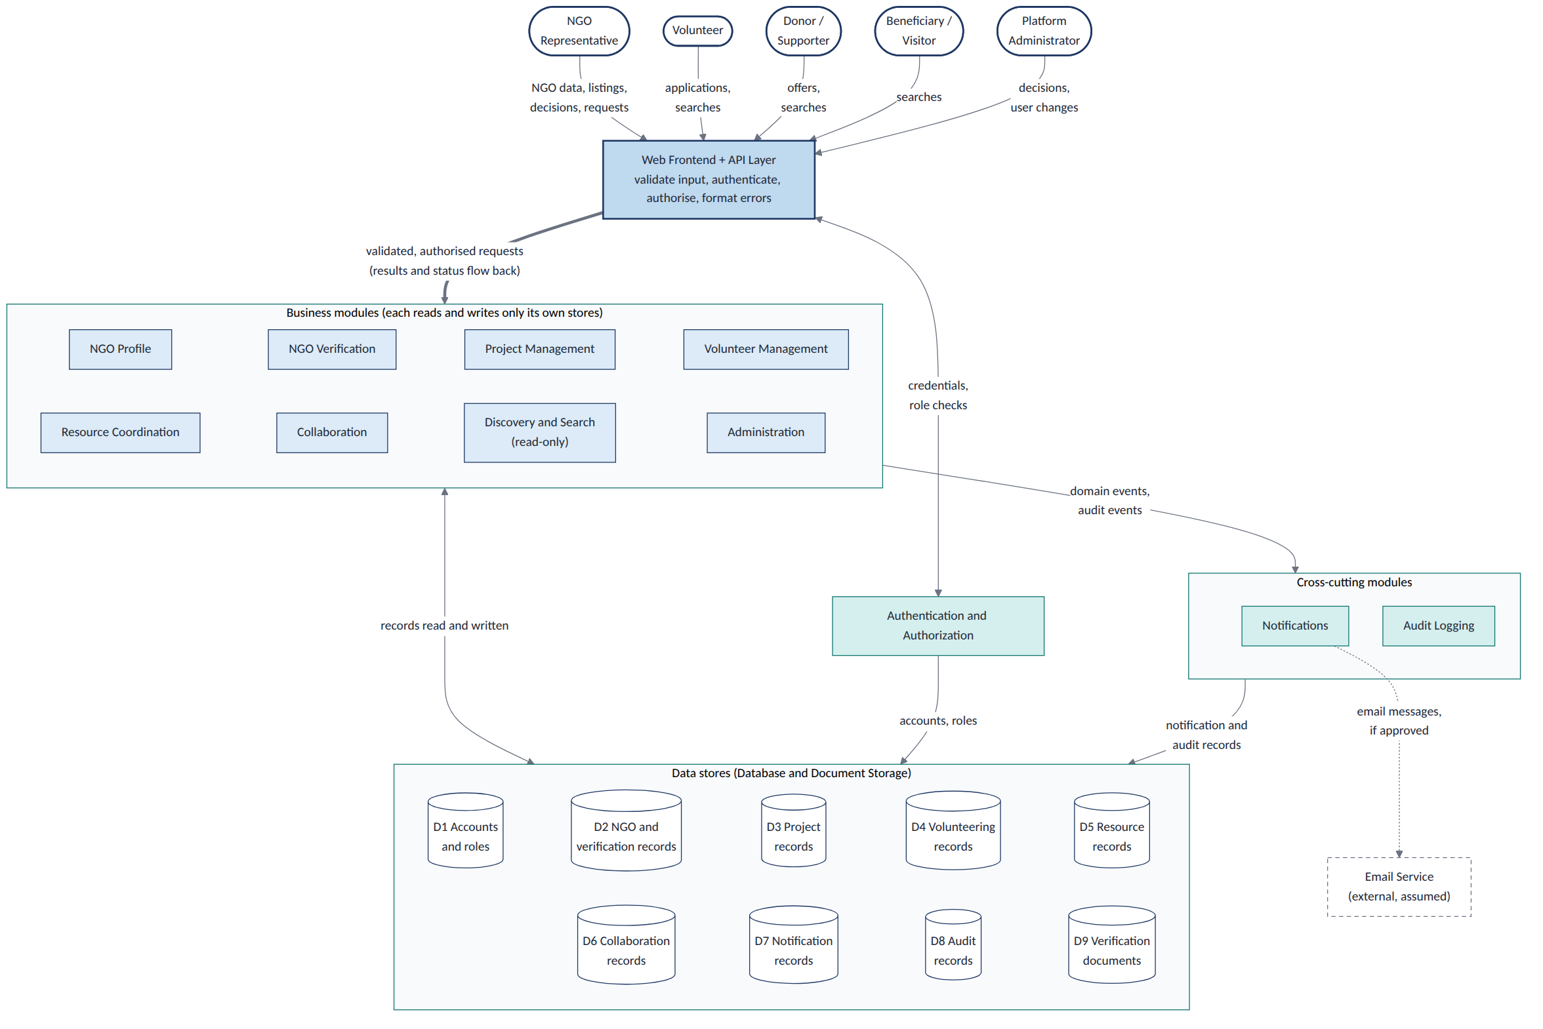

Figure 5: Data Flow Diagram - Level 1
The data flows are divided into six groups in Section 7.2.
- Authentication (DF-01 to DF-03). Users enter their login details. The Authentication module verifies them and provides a signed JWT token containing their role and NGO ID, if applicable.
- NGO Registration (DF-04 to DF-08). An NGO submits its details and documents. The Registration module stores the information and sends an event to notify the administrator that a new application is ready for review.
- Projects and Volunteers (DF-09 to DF-14). NGO staff create projects and publish volunteer opportunities. Volunteers apply, and notifications inform them when their application status changes.
- Resource Management (DF-15 to DF-17). NGOs publish the resources they need and record the resources they receive. Notifications inform the relevant people when a request is fulfilled or its status changes.
- Collaboration (DF-18 to DF-20). One NGO sends a collaboration request to another NGO. The system records the request and notifies both organisations when the request or its status changes.
- Search and Discovery (DF-21 to DF-23). Volunteers, donors, and beneficiaries search for NGOs, services, projects, and resources. Beneficiaries can also send assistance enquiries, which the system records and forwards to the relevant NGO.

7.2 Data flow catalogue
The table lists each numbered flow with its payload and whether it is synchronous (the caller waits) or asynchronous (carried by an event).
ID | From | To | Payload | Protocol / Mode
DF-01 | Web Portal | API Gateway | Login credentials (email, password) | HTTPS POST, sync
DF-02 | API Gateway | Auth Module | Credential validation request | Internal call, sync
DF-03 | Auth Module | Web Portal | JWT token (user_id, role, ngo_id) | HTTPS response, sync
DF-04 | Web Portal | API Gateway | NGO registration form + documents | HTTPS POST multipart, sync
DF-05 | API Gateway | Registration Module | Registration payload | Internal call, sync
DF-06 | Registration Module | PostgreSQL | NGO record (status=PENDING) | SQL INSERT, sync
DF-07 | Registration Module | Document Storage | Uploaded document files | File write, sync
DF-08 | Registration Module | Notification Module | NGORegistrationSubmitted event | Internal event, async
DF-09 | Web Portal | API Gateway | Project creation/update payload | HTTPS POST/PUT, sync
DF-10 | API Gateway | Project Module | Project data | Internal call, sync
DF-11 | Project Module | PostgreSQL | Project record | SQL INSERT/UPDATE, sync
DF-12 | Web Portal | API Gateway | Volunteer opportunity payload | HTTPS POST, sync
DF-13 | API Gateway | Volunteer Module | Opportunity data | Internal call, sync
DF-14 | Web Portal | API Gateway | Volunteer application (cover note) | HTTPS POST, sync
DF-15 | Volunteer Module | Notification Module | VolunteerApplicationReceived event | Internal event, async
DF-16 | Web Portal | API Gateway | Resource requirement payload | HTTPS POST, sync
DF-17 | Resource Module | PostgreSQL | Resource requirement record | SQL INSERT, sync
DF-18 | Web Portal | API Gateway | Collaboration request payload | HTTPS POST, sync
DF-19 | Collaboration Module | PostgreSQL | Collaboration request record | SQL INSERT, sync
DF-20 | Collaboration Module | Notification Module | CollaborationRequested event | Internal event, async
DF-21 | Web Portal | API Gateway | Search query (sector, location, keywords) | HTTPS GET, sync
DF-22 | API Gateway | Directory Module | Search parameters | Internal call, sync
DF-23 | Notification Module | Email/SMS Gateway | Notification payload (email body, recipient) | HTTPS POST, async

7.3 Domain events
Six Domain Events
- NGORegistrationSubmitted. When an NGO submits its registration form and documents, the system sends a confirmation to the NGO Administrator and alerts the Platform Administrator.
- NGOVerificationDecided. When the Platform Administrator approves or rejects an NGO, the system informs the NGO. If approved, the NGO is added to the public directory.
- VolunteerApplicationReceived. When a volunteer applies for an opportunity, the system notifies the NGO Staff who posted it.
- VolunteerApplicationDecided. When NGO Staff accepts or rejects a volunteer's application, the system informs the volunteer of the decision.
- CollaborationRequested. When one NGO requests collaboration with another NGO, the system notifies the receiving NGO's Administrator.
- BeneficiaryInquiryReceived. When a beneficiary sends a request for help, the system forwards the inquiry to the relevant NGO Staff.

8. Detailed NGO Registration and Verification Workflow
━━━━━━━━━━━━━━━━━━━━━━━━━━━━━━━━━━━━━━━

8.1 Scenario and starting conditions
The NGO Administrator of Bright Futures Foundation logs in to the platform and enters the organisation's name, registration number, mission, sector, address, email, phone number, and website. The administrator uploads the registration certificate, PAN card, and address proof. The system validates the details and checks for duplicate registration numbers. If everything is valid, it saves the NGO record with PENDING_VERIFICATION status, stores the documents securely, and creates a verification request. The NGO Administrator receives a submission confirmation, and Platform Administrators are notified about the new application. Finally, the Platform Administrator reviews the details and documents and either approves or rejects the registration. The NGO appears in the public directory only after approval.

8.2 The flow at a glance
Figure 7 illustrates the workflow in chronological order across five phases: submission (steps 1-6), server validation and data storage (steps 7-14), notifications (steps 15-20), admin review (steps 21-33), and the final approval or rejection decision (steps34-41), followed by a status update and user notification.
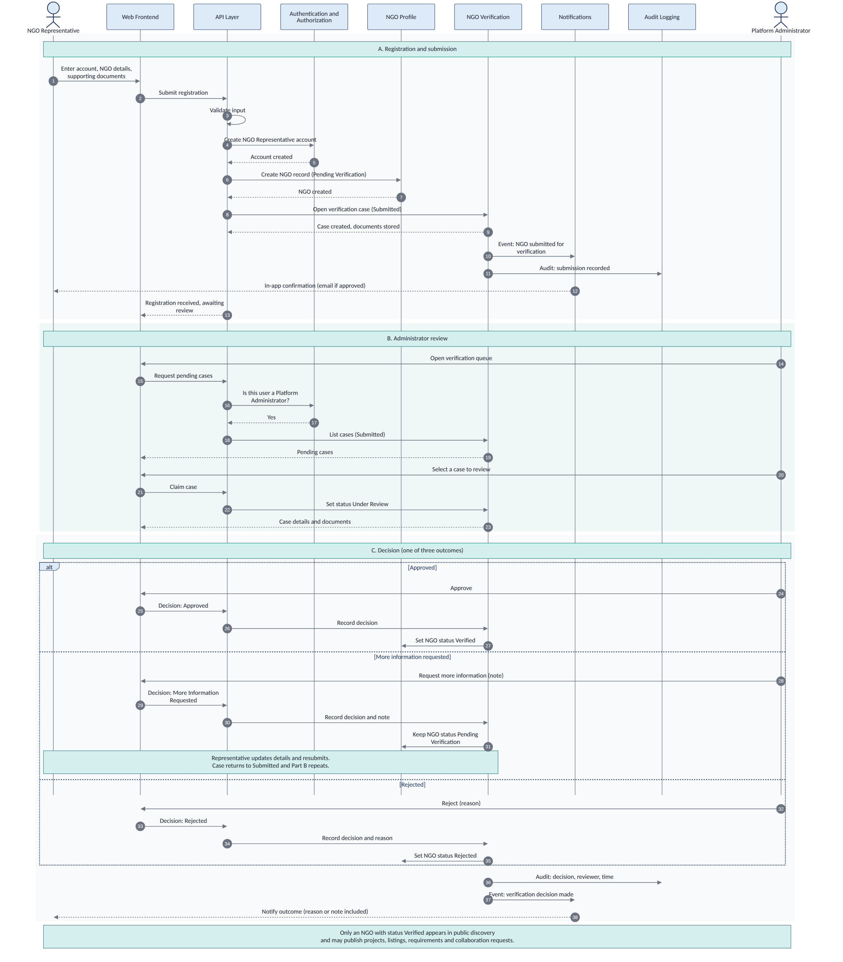
Figure 6: Sequence Diagram - NGO Registration and Verification Workflow

8.3 NGO Collaboration Workflow
The collaboration workflow enables one verified NGO to discover and partner with another. It follows a structured request-response pattern similar to the verification workflow, but between two peer organisations rather than between an NGO and the platform administrator.
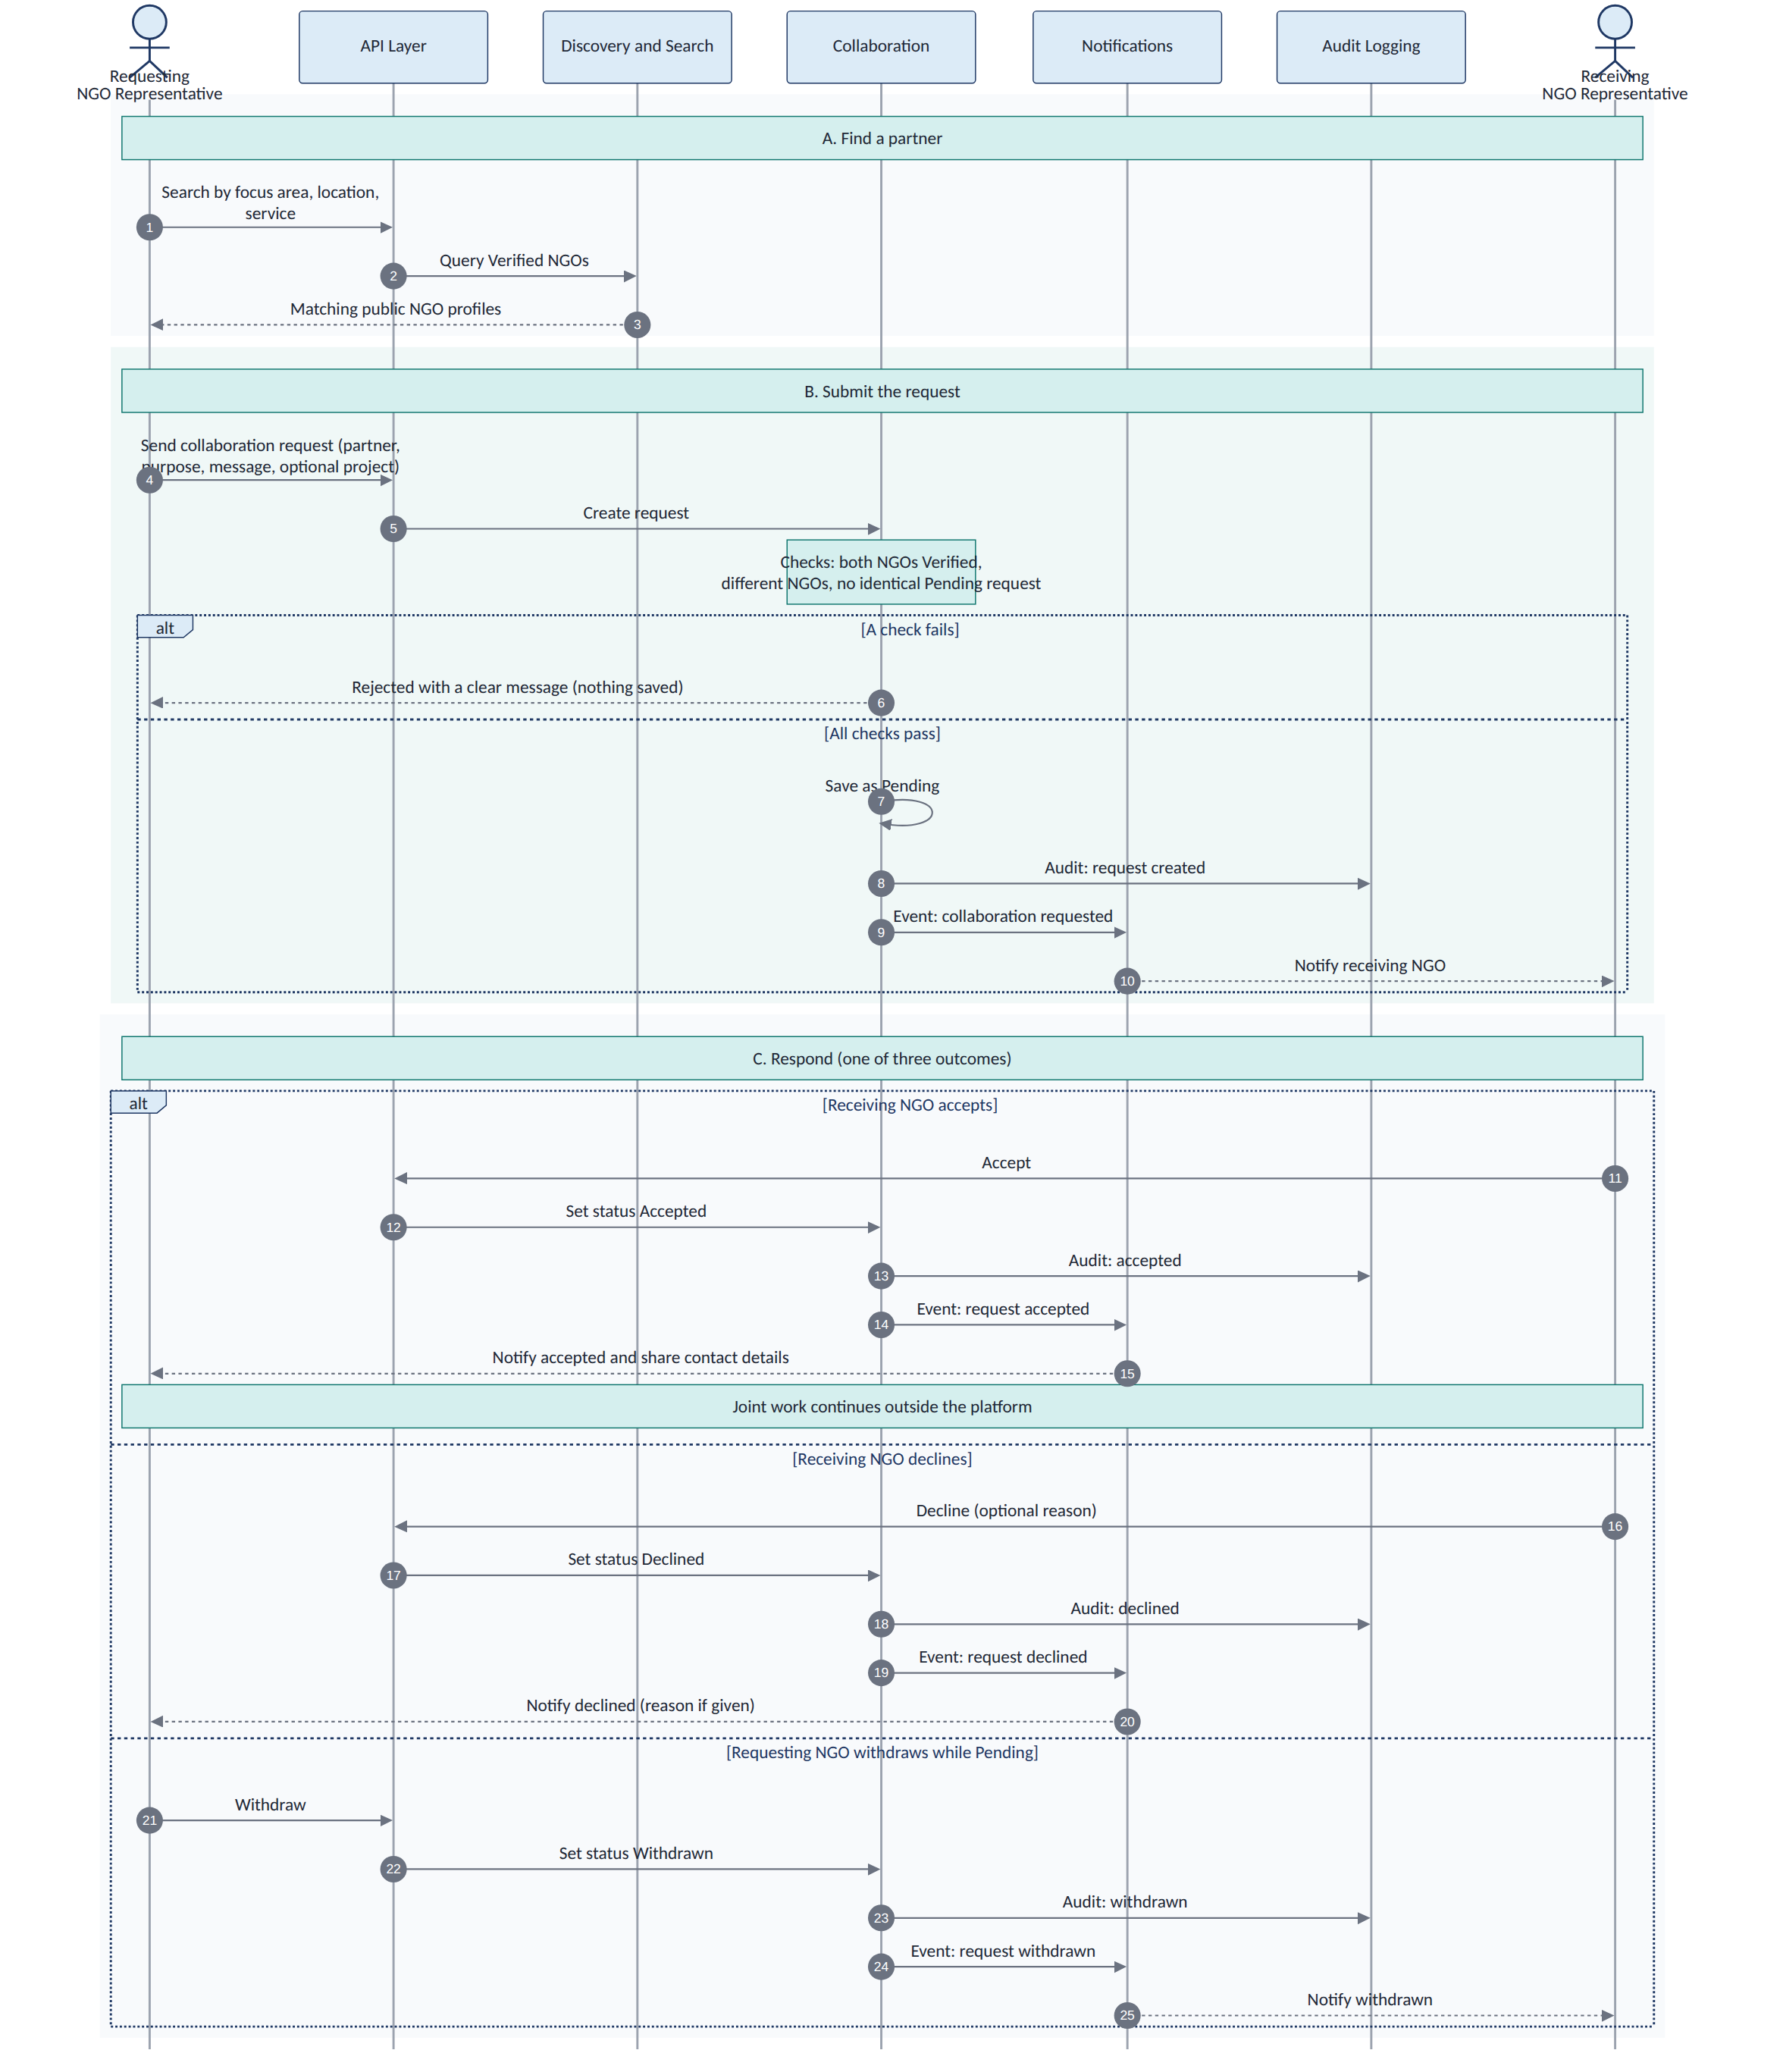
Figure 7: Sequence Diagram - NGO Collaboration Workflow

- Discovery: The requesting NGO searches the directory by sector, location, or services. Only verified NGOs appear in results. The requesting NGO views the target's public profile, including their projects and services.
- Request: The requesting NGO fills a collaboration form specifying the type (joint project, resource sharing, knowledge exchange), scope, proposed duration, and a free-text message. The system validates that both NGOs are verified and that no duplicate active request exists between them.
- Storage: A collaboration_request record is created with status PENDING. The request_id is generated and timestamps are recorded.
- Notification: The target NGO's Administrator receives an email and in-app notification with the request details. The requesting NGO receives a confirmation that the request was sent.
- Review: The target NGO's Administrator reviews the requesting NGO's profile, projects, and the collaboration scope. They can ask questions through the platform's messaging before making a decision.
- Decision: The target NGO either accepts (status → ACTIVE) with terms, or declines (status → DECLINED) with a reason. The requesting NGO is notified of the decision via email and in-app notification.
- Tracking: Active collaborations appear in both NGOs' dashboards. Either NGO can mark the collaboration as COMPLETED when the partnership ends.

9. Security
━━━━━━━━━━━━━━━━━━━━━━━━━━━━━━━━━━━━━━━
- Authentication: All API endpoints except public search and NGO profile viewing require a valid JWT token. Tokens are issued on login and expire after a configurable duration (default: 24 hours). Password storage uses bcrypt with a cost factor of 12.
- Authorisation: Every endpoint checks the user's role from the JWT claims against the required permission. The server rejects unauthorised requests with HTTP 403 regardless of what the client UI shows or hides.
- Transport security: All client–server communication uses HTTPS (TLS 1.2+). The API Gateway terminates TLS and does not forward plain HTTP requests.
- Input validation: All user inputs are validated on both the client and server sides. Server-side validation is authoritative. SQL injection is prevented through parameterised queries. XSS is prevented through output encoding.
- Rate limiting: The API Gateway applies rate limits per IP address and per authenticated user to prevent abuse. Registration and login endpoints have stricter limits to prevent brute-force attacks.
- Document access control: Uploaded NGO documents are stored in a location that requires authentication. Document URLs are signed with time-limited tokens. Only the owning NGO's administrators and Platform Administrators can access verification documents.
- Data isolation: NGO-specific data is partitioned by ngo_id. All database queries that return NGO-specific data include the ngo_id filter. This ensures that one NGO cannot access another's internal data through API manipulation.
- Audit logging: All write operations (create, update, delete) are logged with the user_id, timestamp, IP address, and the operation type. Audit logs are append-only and accessible to Platform Administrators.
- Password policy: Minimum 8 characters, at least one uppercase letter, one lowercase letter, one digit, and one special character. Passwords are never stored in plain text or logged.
- Session management: JWT tokens are stored in HTTP-only cookies or secure local storage. Token refresh uses a separate refresh token with longer expiry. Logout invalidates the refresh token on the server.

10. Self-Review
━━━━━━━━━━━━━━━━━━━━━━━━━━━━━━━━━━━━━━━

Review against the assignment questions
- Does every component have a clear purpose?
Yes. The system has 12 components, and each has a specific job, such as NGO registration, project management, volunteer management, notifications, and administration.

2. Are responsibilities separated properly?
Yes. Each component does its own work. For example, the Registration component handles NGO registration, while the Volunteer component manages volunteer applications.
3. Are the system boundaries clear?
Yes. The system helps NGOs share information, find partners, and manage resources. However, it does not handle payments, issue legal certificates, physically verify NGOs, or check volunteer backgrounds.
4. Can others understand the design easily?
Yes. The document contains diagrams, database structures, workflows, tables, and examples that help developers understand how the system works.
5. Is the problem clearly explained?
Yes. The document explains seven main problems, such as scattered information, difficulty finding NGO partners, volunteer management issues, and problems accessing services.
6. Are users and their responsibilities clear?
Yes. The document explains six types of users, their activities, and what they are allowed to do in the system.
7. Are assumptions and unanswered questions documented?
Yes. The document lists system limitations, assumptions, and unanswered questions to help developers understand what needs further clarification.
8. Is security considered?
Yes. The document explains security measures such as secure login, access permissions, data protection, input validation, and activity tracking.
9. Are design decisions explained?
Yes. The document explains eight important design decisions, why they were chosen, and why other options were not selected.

